
Time Court Residential and Nursing Home Report

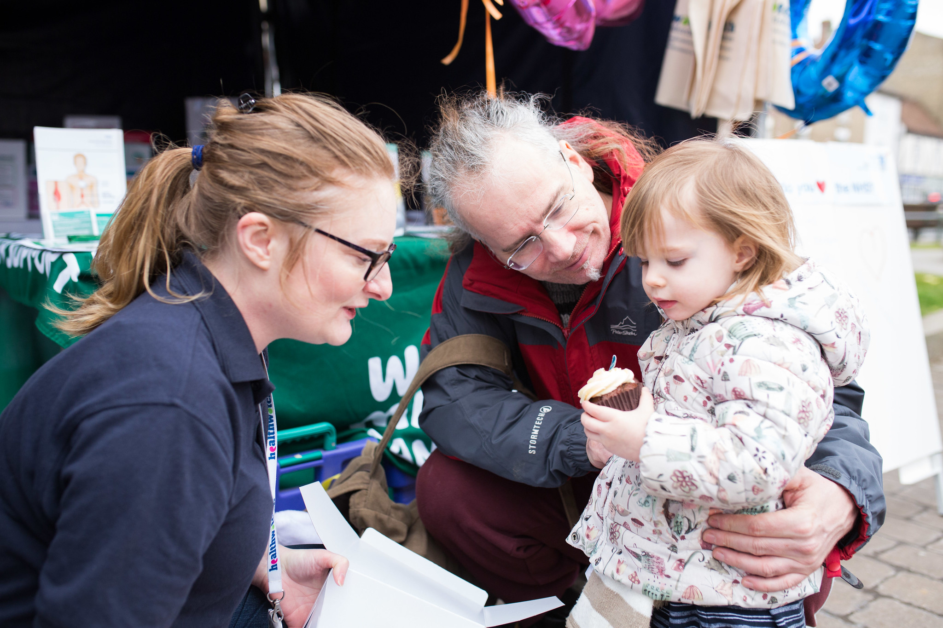
February 2023

Contents
Contents 1
Enter and View 2
Acknowledgements 2
Recommendations 3
Contact Us 6

Enter and view

Healthwatch has a legal power to visit health and social care services and see them in action. Enter & View is not an inspection; we do not look at care plans, medicines management, or clinical issues. The Care Quality Commission (CQC)look at the clinical aspects of a service. We offer a lay perspective. We ask residents, families, and carers, what they think of the service they receive. Our focus is on whether a service works for the people using it.

Acknowledgements

We would like to thank the Manager, staff, residents and relatives of Time Court Residential Care Home for their time and assistance.

Recommendations

Time Court Residential Care Home Report - August 2022
Healthwatch Greenwich visited Time Court Residential Care Home in August 2022 offering the following recommendations:

1. Improve lighting in dimly lit areas.
2. Complete/fill or update memory box on door of bedroom for each resident.
3. Review food preferences and offer greater menu variety.
4. Regular routine dental care visits for residents.

Follow up on recommendations – February 2023
Our authorised representative conducted an announced visit in February 2023 to follow up on the recommendations made to Time Court Residential Care Home.

The Care Home’s Manager, Mary Johnson was informative and provided the required information and evidence.

1. Improve lighting in dimly lit areas.
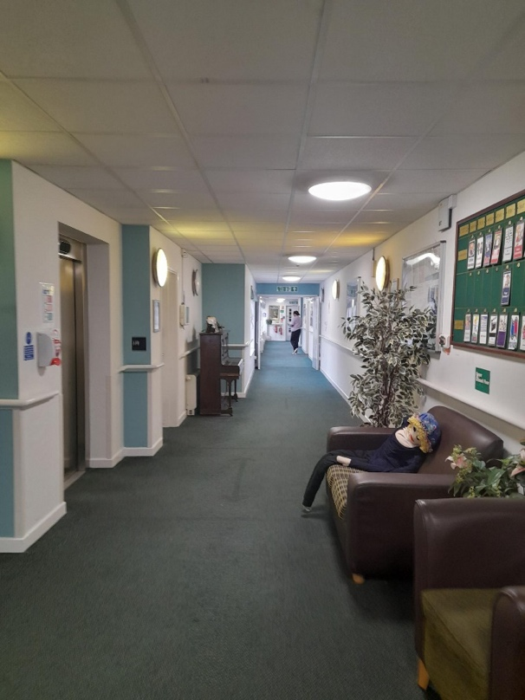
The lighting has been upgraded and all areas are adequately lit.

- Complete/fill or update memory box on door of bedroom for each resident.
All the memory boxes on the resident’s doors have been filled or updated. All residents have a personalised memory box.

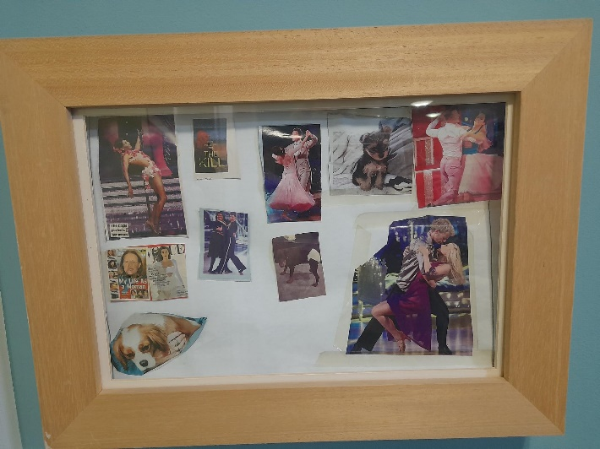


- Review food preferences and offer greater menu variety.
Time Court has an updated menu with more culturally inclusive options.
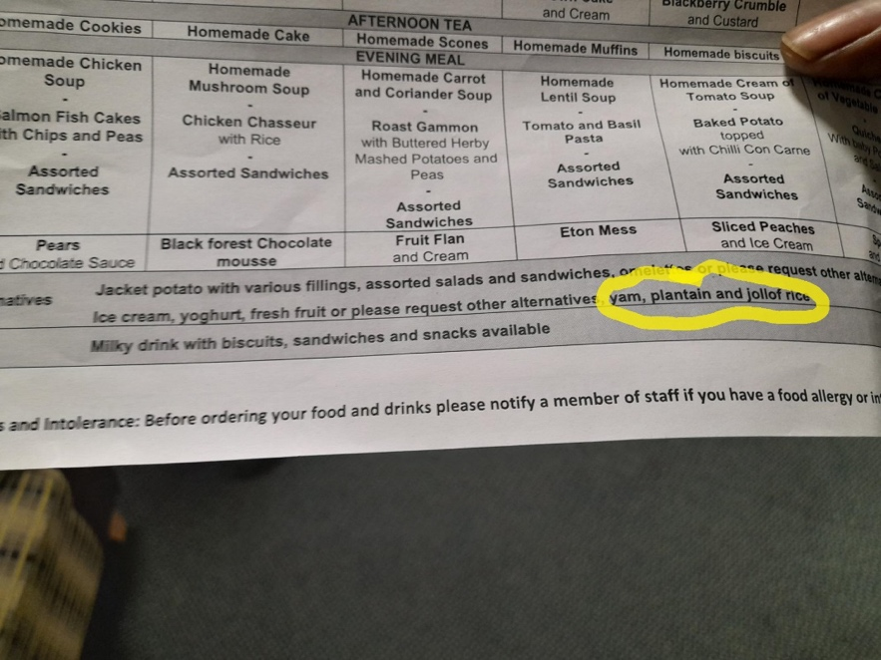

- Regular routine dental care visits for residents.
Dental care is included residents care plans and daily oral hygiene is followed. However, residents don’t have regular, routine dental visits. For urgent dental treatment, staff contact 111.

Gunnery House
9-11 Gunnery Terrace
Woolwich, London
SE18 6SW


www.healthwatchgreenwich.co.uk
t: 020 8301 8340
e: info@healthwatchgreenwich.co.uk
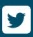
@HWGreenwich
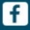
Facebook.com/Healthwatchgreenwich

