

Brook House Residential and Nursing Home Report
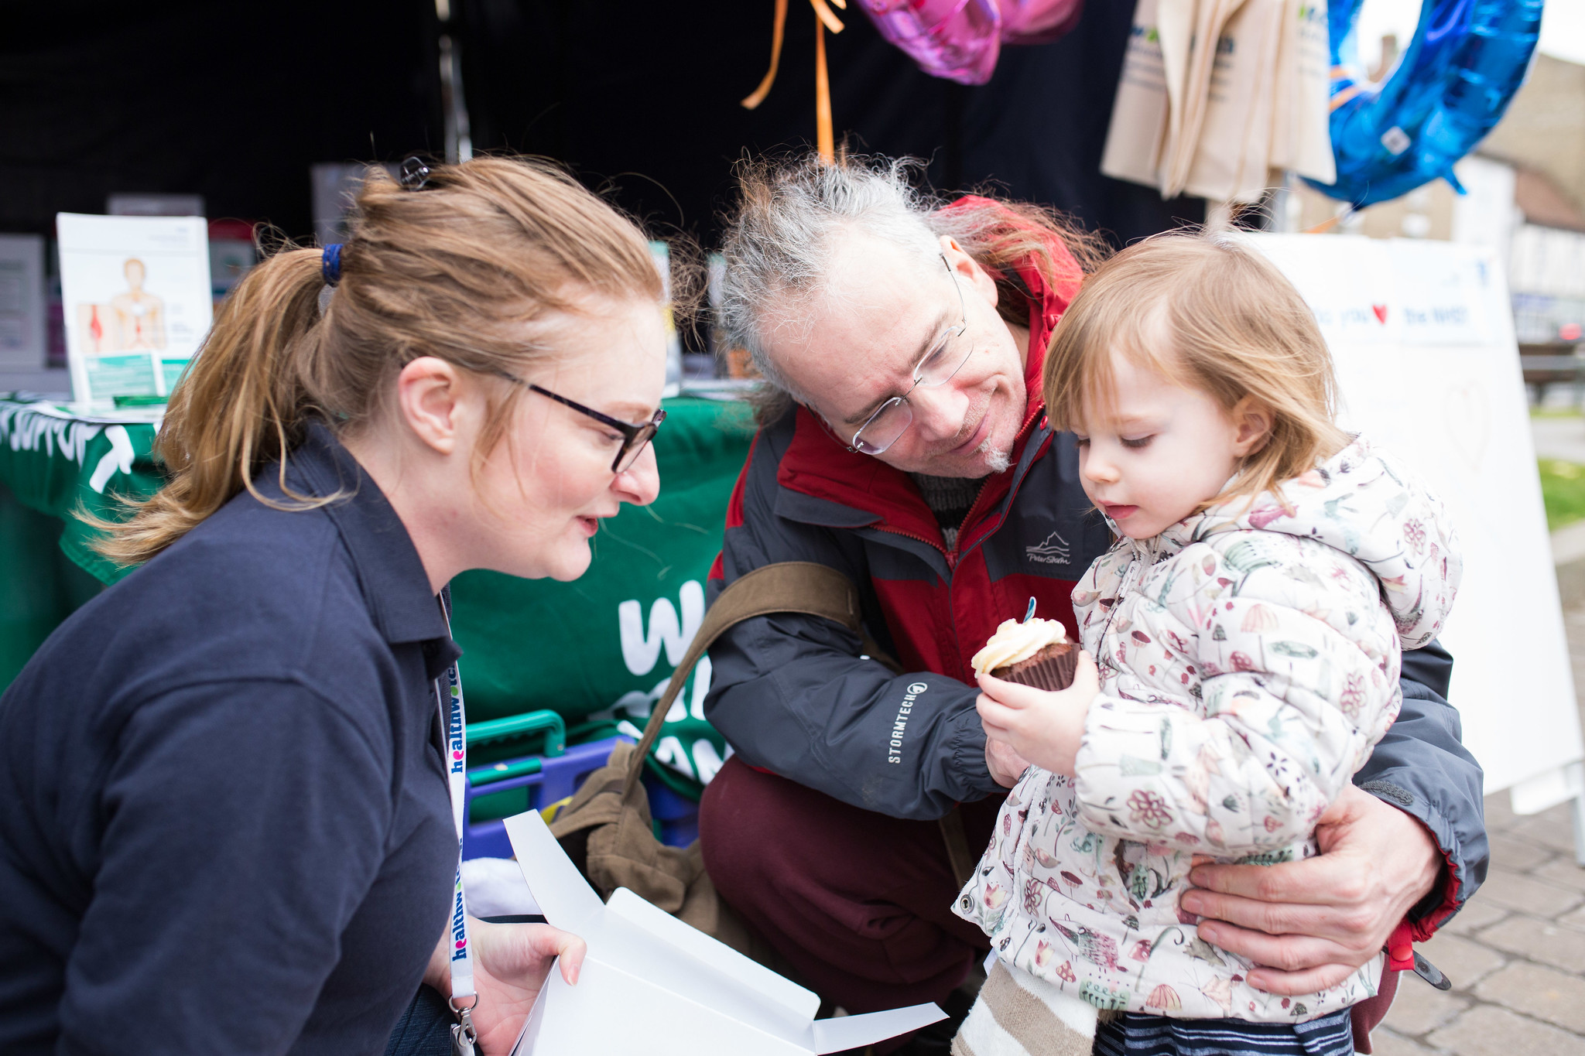
February 2023

Contents
Contents 1
Limitations 2
Recommendations 3
Contact us 7

Enter and view visits

Healthwatch has a legal power to visit health and social care services and see them in action. Enter & View is not an inspection; we do not look at care plans, medicines management, or clinical issues. The Care Quality Commission (CQC)look at the clinical aspects of a service. We offer a lay perspective. We ask residents, families, and carers, what they think of the service they receive. Our focus is on whether a service works for the people using it.

Acknowledgements

We would like to thank the Manager, residents and staff of Brook House for their time and assistance.

Limitations

Our Authorised Representative was unable to visit parts of the care home due to a Covid outbreak.

Heading

Recommendations

Brook House Residential and Nursing Home Report - June 2022
Healthwatch Greenwich visited Brook House and offered the following recommendations:

- Display staff photos/names in communal areas for residents/visitors.
- Increase staff training for resident wellbeing.
- Encourage engagement with spiritual leaders/community groups.
- Refurbish walls/handrails/doors in disrepair.
- Modernise lounge/dining areas to improve resident space.
- Improve display of dietary requirements in the kitchen.
- Organise regular dental care visits for residents.

Follow up on recommendations – Feb 2023

Our authorised representative conducted an announced visit in February 2023 to follow up on the recommendations made. The Care Home’s Manager, Jaqueline Pedrix, provided information and evidence.

1. Display staff photos/names in communal areas for residents/visitors.
Action Taken: A board to display names and photographs has yet to be installed.

2. Increase staff training for resident wellbeing.
Action Taken: Staff receive dementia care training from the Greenwich and Bexley Care Home Team, and health/wellness coaching from a Charlton Athletic service.

3. Encourage engagement with spiritual leaders/community groups.
Action Taken: The care home doesn't offer regular visits to local places of worship. Weekly music sessions are delivered by Shine for Dementia. The Care Home's Facebook page is regularly updated, showcasing a variety of activities for residents.

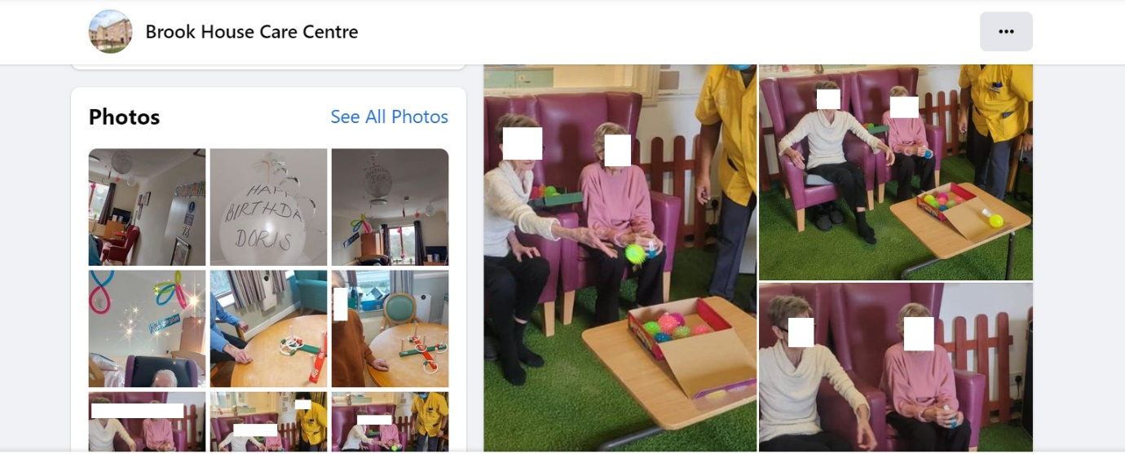
4.Refurbish walls/handrails/doors in disrepair.
Action Taken: The care home shared photographs of ongoing refurbishment.
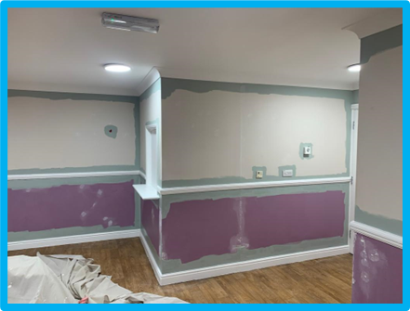

5.Modernise lounge/dining areas to improve resident space.
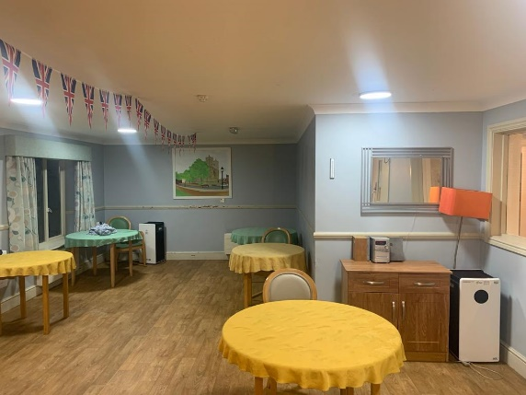
The care home provided photographic evidence of the ongoing refurbishing work.

6. Improve display of dietary requirements in the kitchen.
The care home has clear dietary information for kitchen staff and has expanded the regular menu with additional ethnic options for more food choices.

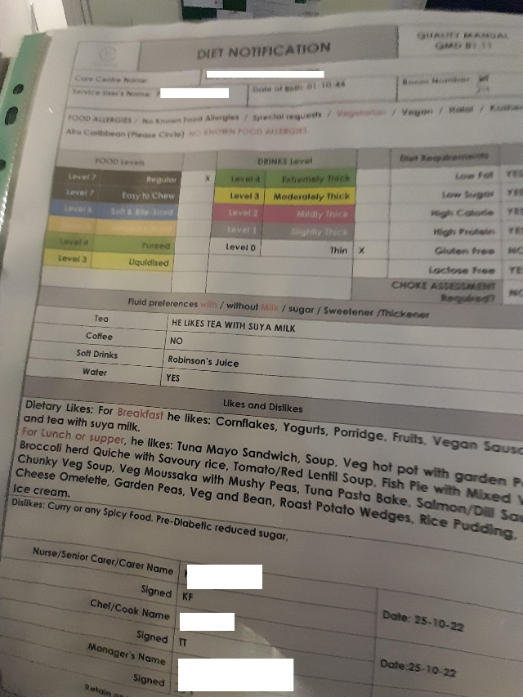
7.Organise regular dental care visits for residents.
Oral care is included in daily hygiene routines for residents, and staff refer them to specialists as necessary.

Contact Us
If you require this report in an alternative format, please contact us.

We confirm that we are using the Healthwatch Trademark (which covers the logo and Healthwatch brand) when undertaking work on our statutory activities as covered by the licence agreement.
© Copyright Healthwatch Greenwich 2020

Gunnery House
Gunnery Terrace
Woolwich
London
SE18 6SW


www.healthwatchgreenwich.co.uk
t: 020 8301 8340
e: ​info@healthwatchgreenwich.co.uk
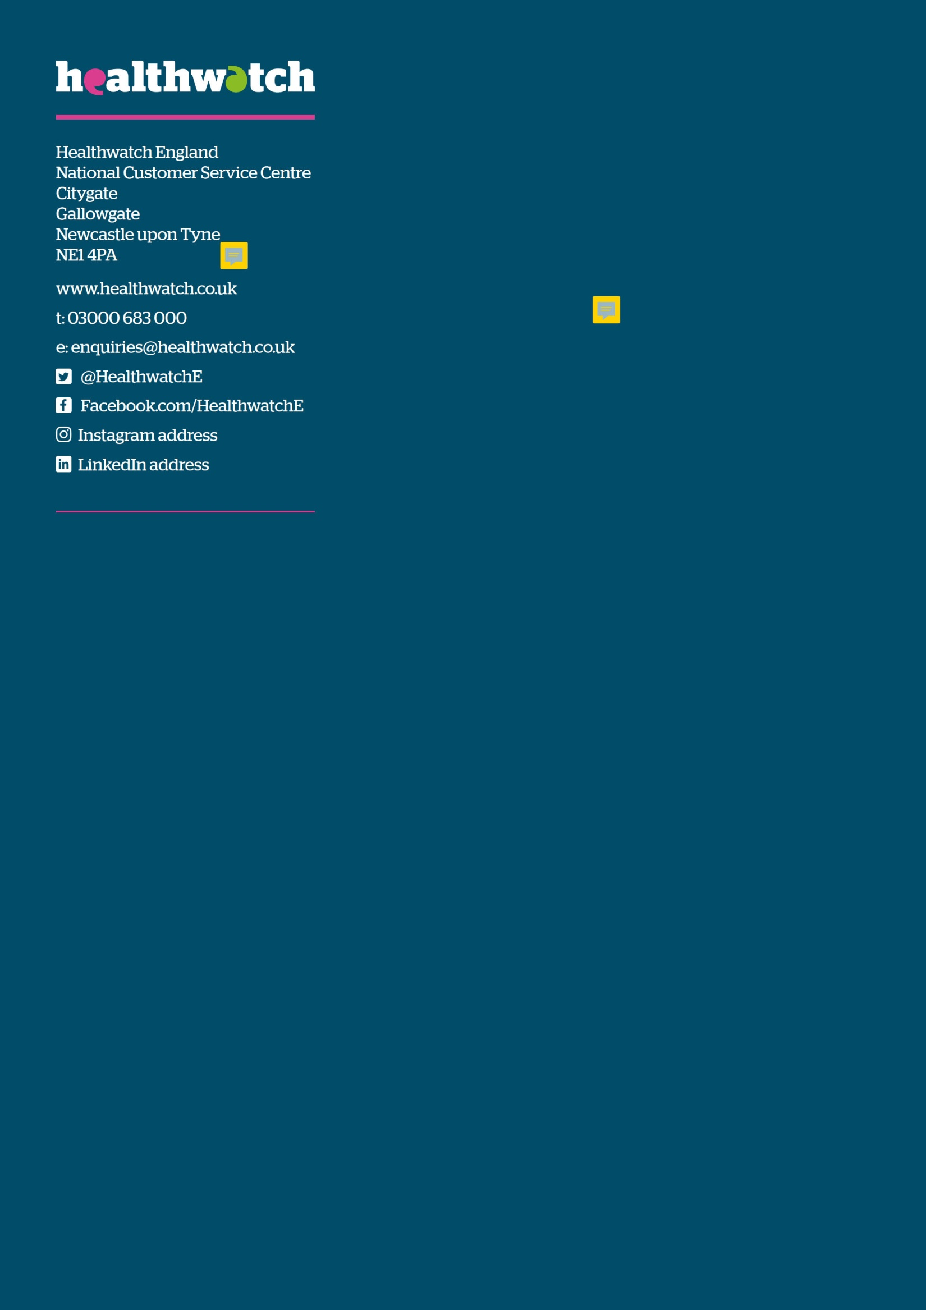
@HWGreenwich
Facebook.com/Healthwatchgreenwich

